RAJDHANI COLLEGE

(UNIVERSITY OF DELHI)

PRACTICAL FILE

RESEARCHMETHODOLOGY

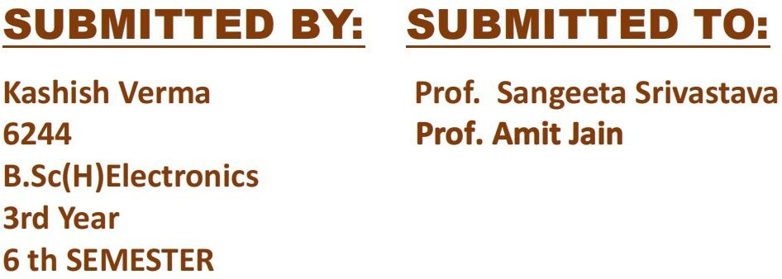

PRACTICAL 1 : Research Paper Analysis
Paper Link: https://www.sciencedirect.com/science/article/abs/pii/S0038110100002410

Task:-

How many people have authored this paper?
There are 4 authors of this research paper ares A. Motayed, T.E. Browne, A.I. Onuorah, S.N. Mohammad.

what are the major sections in this paper ?
The major sections of this abstract , introduction ,amplifier configurations , experimental methods , results and conclusions, reference.

Write about 5-6 lines summary of the paper?
It is about the daily we use the amplifiers in the daily life of the many electronics
Circuits so in this research paper its about the how the amplifiers work about some of their amplifiers face the problems of distortion of the wave at very high frequencies and how it helps in our daily modern life and can be improve a further little more rather than the previous one .

What are the Reference Papers used for this study ?
  - Searle CL, Boothroyd AR, Angelo EJ, Gray PE, Pederson DO. Elementary circuit properties of transistors. New York:...
  - Jaeger RC. Microelectronic circuit design. New York: McGraw-Hill; 1997. p....

Is this paper available on Google Scholar ,Scopus ,Web of Science or IEEE Xplore ?
Yes it is available on the only on Google Scholar

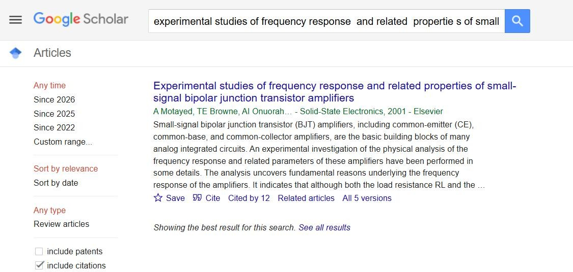

What are the metrics of this paper (Impact Factor, h-index, citation count)?
Citation Count = 12

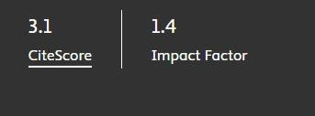

PRACTICAL 2 : Data Collection and Descriptive Analysis

A Descriptive Study of India’s World Happiness Ranking (2015–2024)
Kashish Verma
Rajdhani College, University of Delhi kashishv969@gmail.com
January 28,2026

Abstract
Happiness is an important indicator of social and economics well-being of a country. The Wolrd Happiness Report provides annual happiness scores and global rankings for countries based on surevey. This study to analyse the happiness trends from 2015 to 2024 using descriptive statistical techniques and data visualization method. This analysis includes mean , median, mode and standard deviation using graphical representation.
Keywords: Happiness Index , Rank , descriptive statistics , Trend analysis , india , world happiness report

Introduction
Happiness rankings are widely used to assess the overall well-being of nations by comparing social, economic, and psychological conditions. India’s position in the World Happiness Report has fluctuated significantly over the past decade. Understanding these changes through statistical analysis helps identify long-term patterns in relative wellbeing.

Objectives of the Study
- To analyze India’s World Happiness Rank using secondary data.
- To compute descriptive statistical measures.
- To identify trends and patterns in the ranking over time.

Data Description
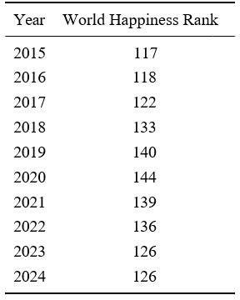

Results and Statistical Analysis
Let the dataset be:
X = {117, 118, 122, 133, 140, 144, 139, 136, 126, 126}
Number of observations: n = 10

Mean
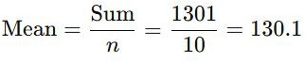

Median
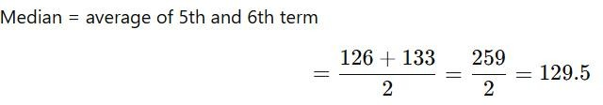

Mode

Standard Deviation
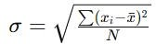
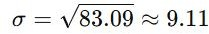

Trend and Pattern Analysis
The data show a continuous deterioration in India’s World Happiness Rank from 2015 to 2020, reaching the lowest position of 144 in 2020. This indicates a strong negative trend during this period. After 2020, the ranking improves gradually, reaching 126 by 2023. However, the rank remains unchanged in 2024, indicating stagnation rather than sus- tained improvement. Overall, the pattern suggests long-term decline followed by partial recovery.

Conclusion
This descriptive study reveals that India’s World Happiness Ranking experienced signifi- cant decline over the first half of the decade, followed by limited recovery in recent years. The moderate standard deviation indicates noticeable variability in rankings. Since the ranking is a relative measure, further studies incorporating additional variables could provide deeper insight into national well-being.

References
CountryEconomy. World Happiness Index – India.
https://countryeconomy.com/demography/world-happiness-index/india

PRACTICAL 3 : Data Visualization

Graphical Representation of India’s World Happiness Ranking (2015-2024)

Objective
To present the data of India’s world happiness ranking in graphical form and understand the pattern over time.

Dataset Used
The data is based on india’s ranking in the World Happiness Report from 2015 to 2024.


Graph and Interpretation
  - Line Graph
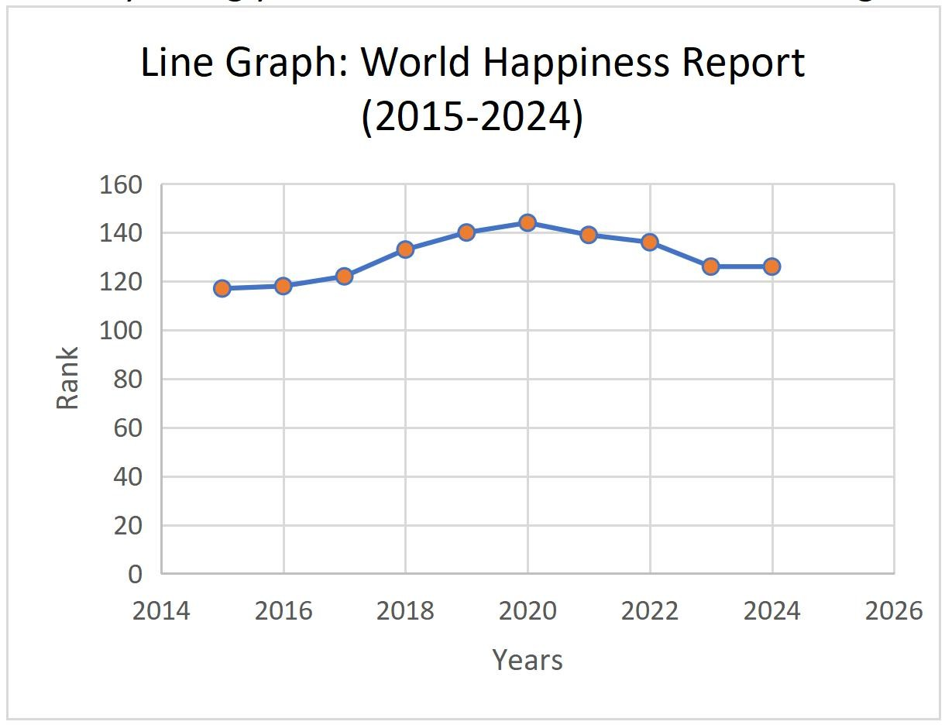
A line graph is plotted by taking years on the horizontal axis and ranking on vertical axis.

The graph shows that India’s position kept getting worse from 2015 to 2020, reaching its lowest point in 2020. After that, the line moves upward, which means the ranking is improving. In the last two years, the line becomes almost straight, showing that the rank has become stable.

Bar Graph
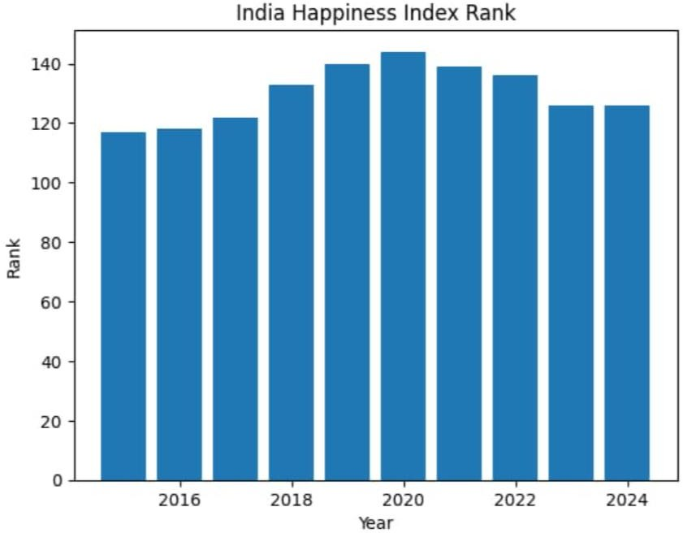
A bar chart is used to compare the ranking of each year separately.
From the bars, it is easy to see that the height increases from 2015 to 2020, which indicates a fall in ranking. After 2020, the height of bars starts decreasing, showing improvement. The bars for 2023 and 2024 are equal, meaning there is no change in rank during these years.

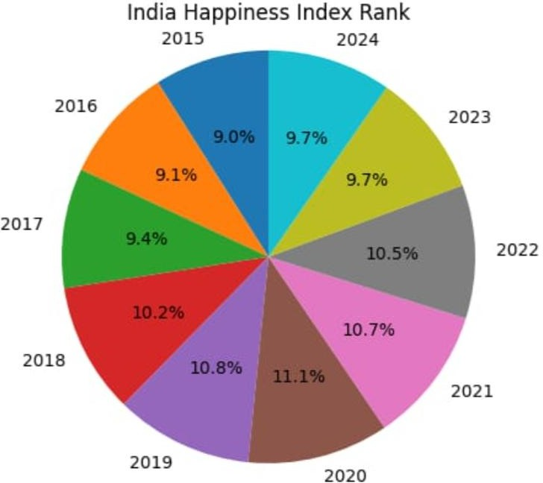
Pie Chart
The pie chart shows that most of the data falls in the low-performance category. Only a few years come under better or average categories. This means India has mostly been ranked lower in terms of happiness during these years.

Conclusion
From the graphs, it can be understood that India’s happiness ranking first declined for several years and then started improving after 2020. The recent data shows a positive trend, although the overall position is still not very high. Graphs help in clearly understanding these changes over time.

References
CountryEconomy. World Happiness Index – India.
https://countryeconomy.com/demography/world-happiness-index/india

PRACTICAL 4 : Curve Fitting Using Excel

Click here to open Excel file

- Abstract

PRACTICAL 5 : Comparative Analysis
Comparative Analysis Report (Literacy Rate in India: Men and Women) (By:Deepak Kumar and Kashish Verma)

This study compares the literacy rates of men and women in India for the years 1951and 2011 (estimated). The analysis shows that literacy rates have improved for both genders over time. Male literacy increased from 27.15% to 80.88%, while female literacy rate from
8.86% to 64.63%.

Data Overview
The data we used for analysis:
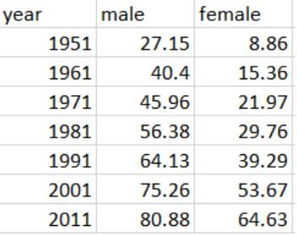

Comparative Graph
The data is plotted using grouped Bar-Graph to clearly compare male and female literacy rates.
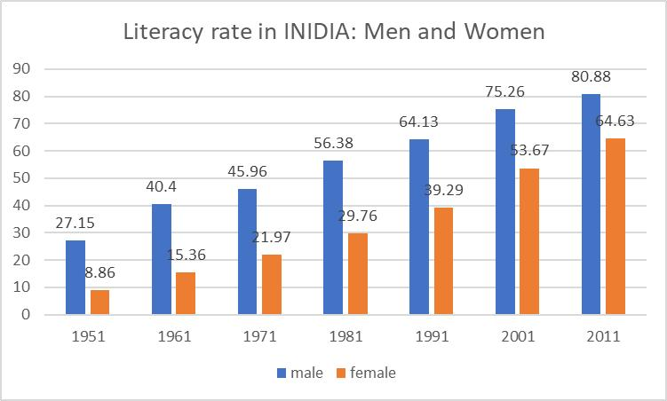

Similarities
    - In Every decade, literacy rate of both men and women increased.
    - The trend for genders us upward( slowly increase over the time).
    - We see biggest improvement from 1991 to 2001 for both.

Differences
    - In all years, male literacy rate is higher than female literacy rate.
    - The gap we see between men and women was very large in early year(1951 to 1981).
    - Female Literacy rate increased faster after 1981 compare to earlier decades.

Reasons for observed differences
    - Old social mindset- Earlier families preferred education boys
    - over girls.
    - Early marriages of Girls
    - Lack of School in Rural Areas
    - Government shcemes After 1990- Programs for girs education helped female literacy grow faster in later years.

Conclusion
The graph clearly shows that literacy in India has improved continuously from 1951 to 2011 for both men and women. However, men have always had a higher literacy rate than women. The good thing is that the gap between men and women is slowly decreasing, especially after 1991. This shows that India is moving towards gender equality in education. Still, more efforts are needed to completely remove the literacy gap and ensure equal education opportunities for both men and women.
- References https://www.mospi.gov.in/sites/default/files/reports_and_publication/statistical_publication/social_statis tics/WM17Chapter3.pdf

PRACTICAL 6 : Modelling and Simulation Techniques

Monte Carlo Simulation of RC Low-Pass Filter

- Define the System Model
The system is an RC low-pass filter circuit where the output voltage depends on the resistor and capacitor values. It allows low-frequency signals to pass while attenuating high-frequency signals.
System Equations
- Transfer Function (Magnitude)
H(f) = 1 / √(1 + (2πfRC)²)
- Output Voltage
Vout = Vin × H(f)
- Expanded Output Formula
Vout = Vin / √(1 + (2πfRC)²)
- Cutoff Frequency
fc = 1 / (2πRC)

Uncertain Parameters
The uncertain parameters due to manufacturing tolerances are R (Resistor) C (Capacitor)
Each component has a tolerance of ±5%, meaning values vary between 95% and 105% of nominal values.

Defining Probability Distributions
Each parameter follows a uniform distribution within ±5% tolerance R ~ U(950, 1050) Ω C ~ U(95nF, 105nF)

Monte Carlo Simulation Concept
Monte Carlo simulation involves generating random values of R and C within their tolerance ranges and computing the corresponding output voltage using the system equations.

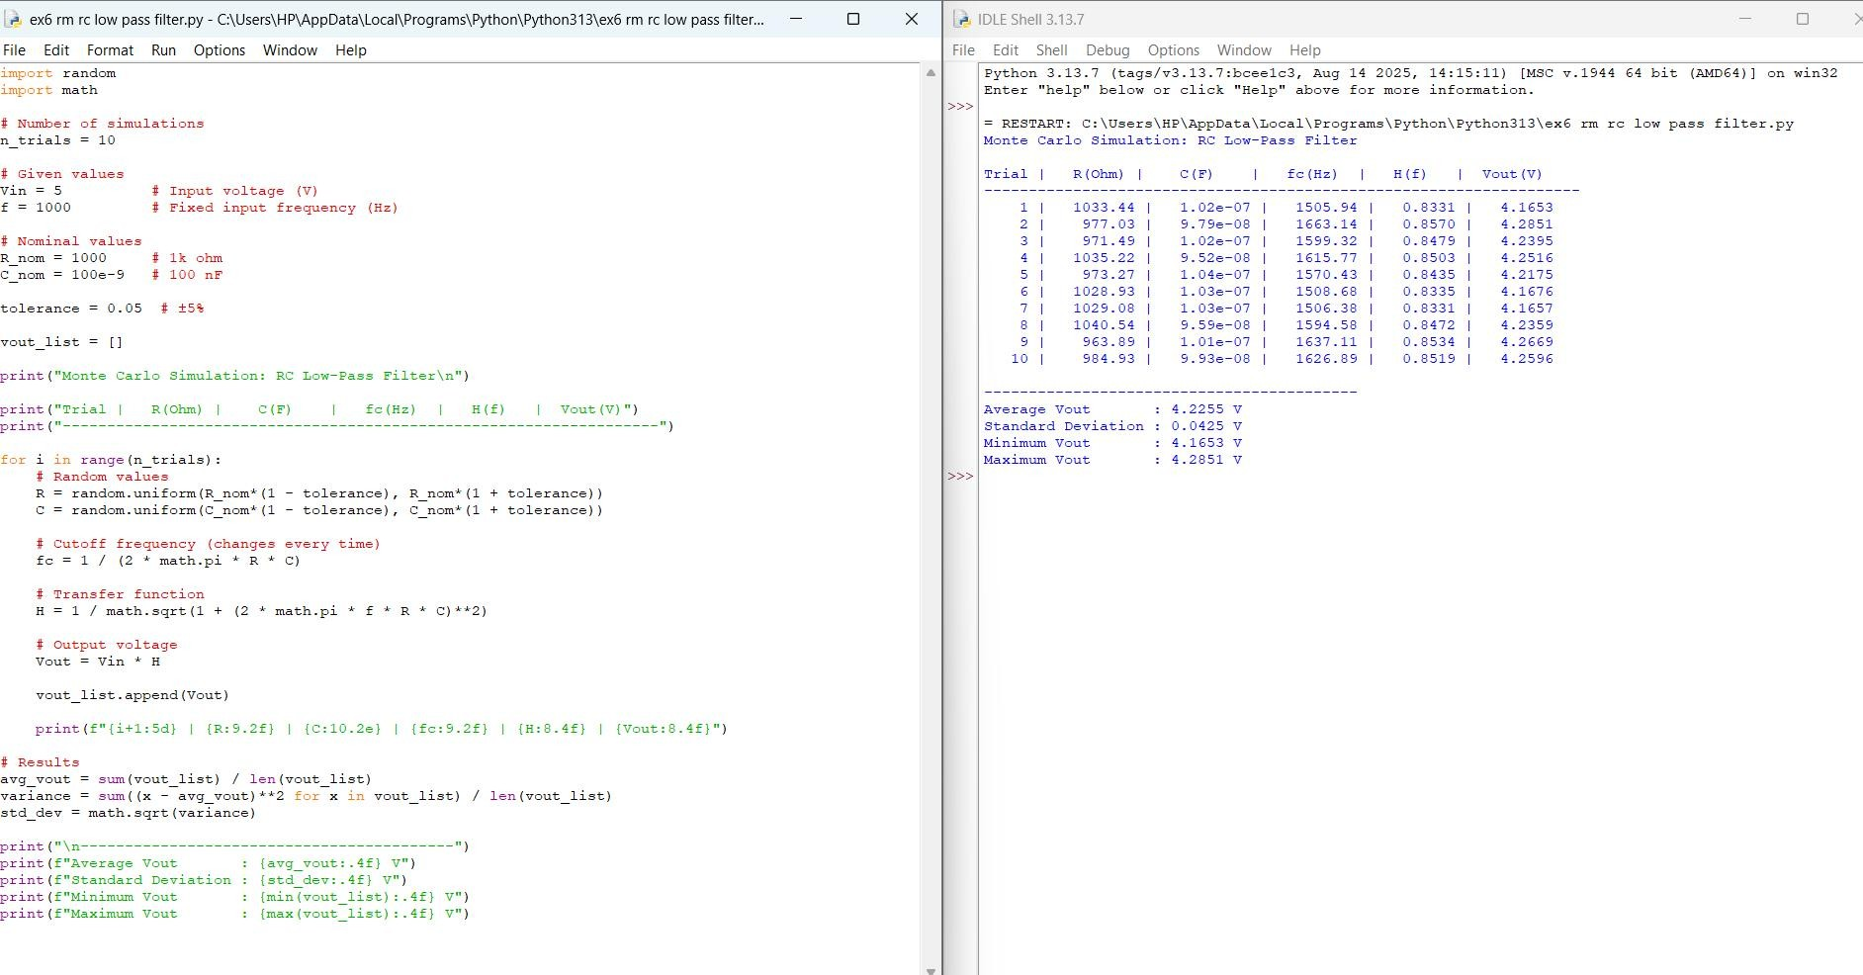
- Results Analysis
As R × C increases, output voltage decreases As R × C decreases, output voltage increases
Maximum output occurs when R × C is minimum
- Conclusion
Monte Carlo simulation helps analyse the effect of component tolerances on circuit performance. In an RC low-pass filter, variation in resistance and capacitance leads to changes in cutoff frequency and output voltage.

